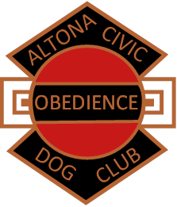**Altona Civic Obedience Dog Club Inc.**

**Notice of Annual General Meeting to be held at the ACODC Inc.**

**Bluegum Drive, Altona on Sunday 4th December 2022 at 11.00 a.m.**

Committee Nomination Forms, due no later than 7th November 2022, can be handed in at the office on the 6th November or emailed to the Club’s Secretary at [info@altonadogobedience.org.au](mailto:info@altonadogobedience.org.au)   
Nomination Forms received after 7th November 2022 will be invalid.

Membership Renewal Forms will only be accepted from **1st November to 30th November 2022**. Member’s renewals received after 30 November will cause the Member to incur another Joining Fee of $50.00 per Member plus the Annual Training Fee.

PRESIDENT SECRETARY

Simon Luketic Kerrie Scully

MR SIMON LUKETIC MRS KERRIE SCULLY